**Step by Step Procedure to Apply for a BLUE CARD updated Nov 2024**

**FIRST STEP:**

1. Applicant needs to have a **Queensland Department of Transport and Main Roads (TMR) product** eg Drivers Licence, Learners Licence or QLD Transport Photo Identification Card <https://www.qld.gov.au/transport/licensing/proof-of-age>

To **proceed** to obtain a Bluecard – they MUST have one of these proof of ID cards.

NOTE FROM A PARENT on 26.11.24 :

The lady at Queensland Transport advised that an Q Transport ID card would cost $77 but **creating her an identity and subsequent Customer Reference Number is all that is required for a Blue Card, and free of cost.**

She did take Student’s photo which now accompanies her file with QLD Transport.

1. Applicant navigates to the [Bluecard online portal](https://my.bluecard.qld.gov.au/login) and registers an account.

Registration is a one time process.

Applicant will need to validate their identity using a **Queensland Department of Transport and Main Roads (TMR) product**.

This being a Drivers Licence, Learners Licence or Photo Identification Card <https://www.qld.gov.au/transport/licensing/proof-of-age>

If successful, the applicant is provided with an online account number.

**Applicant is advised to provide their online account number to NCC, please email me with your online account number.**

**The OFFICE will then create a link to the applicant on the Bluecard Organisational Portal.**

**SECOND STEP:**

The applicant is notified via SMS or email of the successful link with your organisation.

They are now able to complete and submit their online application for their volunteer or student blue card.

**THIRD STEP:**

Blue Card Services receives and processes application.

Most online applications for people with no police information should be processed within five business days. It might take longer if further information is required or if we receive police or disciplinary information.

Blue Card Services notifies the applicant and your organisation of the outcome (successful or unsuccessful).

The portal will reflect the updated status.

For Further information, see the Flyer from Qld Government (pages 1 & 4) as per the attached below.

Page 1

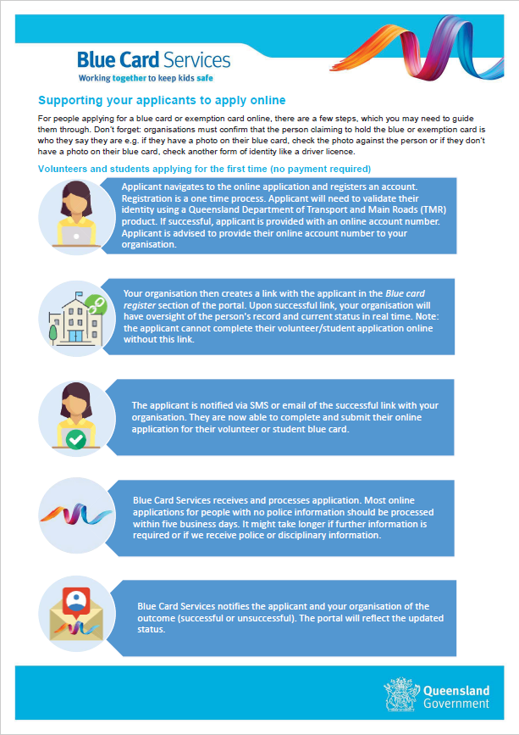

Page 4

